## 1.Table Structures:

### a. Create a books table with these essential fields:

* book_id (Primary Key)
* title
* author
* borrowed_date (YYYY-MM-DD)

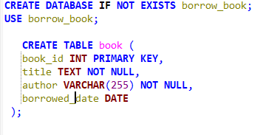

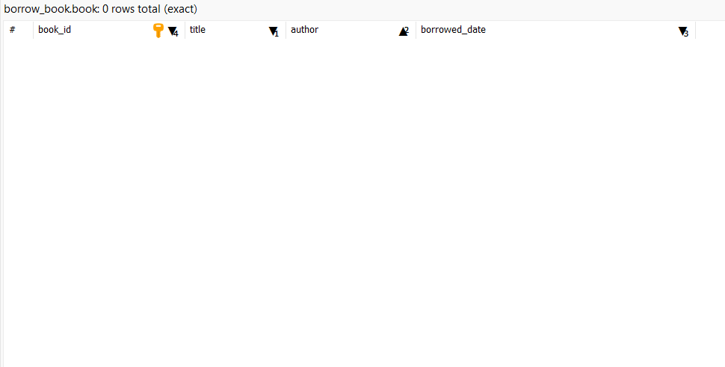

## 2. Required Operations:

### a. Data Entry:

* Add at least 5 books
* Include title, author, and borrowed_date
* Use proper date format (YYYY-MM-DD)

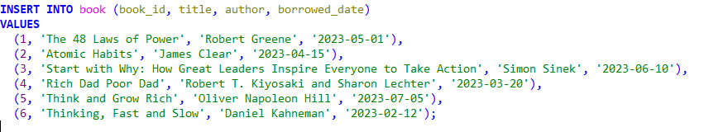

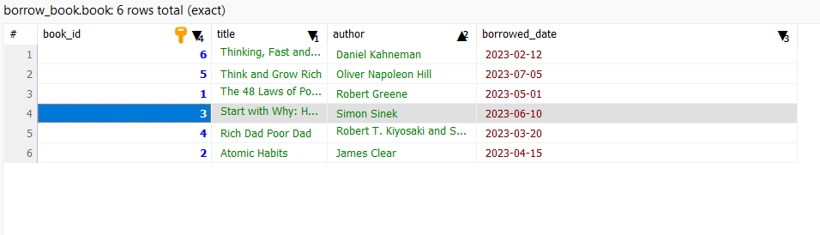

### 

### 

### 

### 

### 

### 

### 

### b. Basic Queries:

* List all books

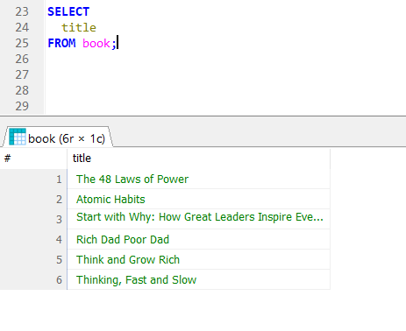

* Find books by author

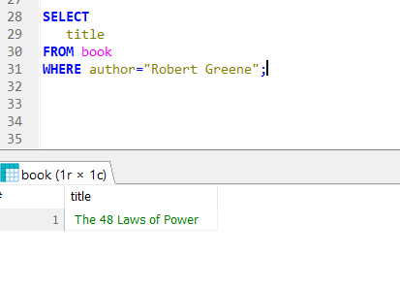

* Find books borrowed on a specific date

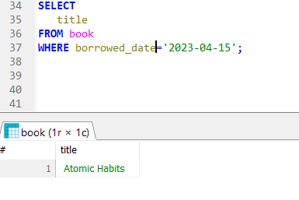

* Find books borrowed after a certain date

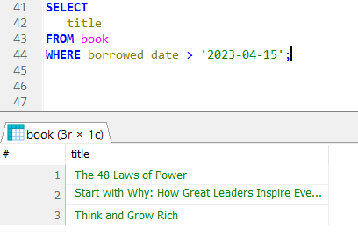

## c. Data Manipulation:

* Update borrowed_date

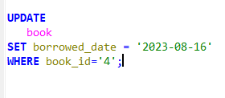

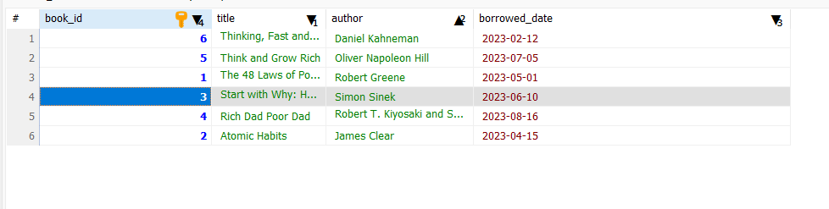

* Delete a book

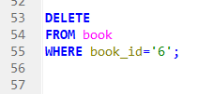

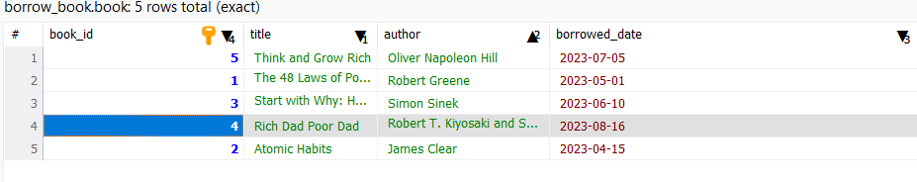

* Re-add a deleted book

